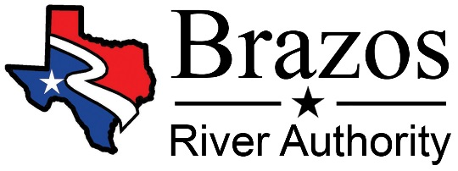
Application for Interruptible Water
Calendar Year 2022

Submit Request To: Brazos River Authority New Customer
P.O. Box 7555 Current or Previous Customer Waco, Texas 76714-7555

BRA Contacts: Upper Basin: Jeff Sammon 254-761-3132 / Jon Dulus 254-761-3274
Central Basin: Amy Muttoni – 254-761-3165
Lower Basin: Cathy Dominguez – 254-761-3176

Contract to be issued to:
Please provide the individual or company name and address that should be
noted on any official contract documents.
Mailing Address: County:
Telephone: Fax:
Email:
Will invoices be sent to the same address? Yes No (If no, please enter the mailing address for invoices):

Requested amount of water per year in acre-feet (minimum of 10 AF): acre-feet
Purpose Water is to be used for:
Industrial Agricultural / Irrigation
Mining Other Non-Agricultural Irrigation (golf course, park watering, etc.)
Briefly describe use:
Diversion Location(s) (where you plan to locate your pump): County
From which reservoir: OR from which river or stream:
List latitude & longitude of diversion location(s):

ALSO, please give general description of location for confirmation of points.

Application Fee (Non-Refundable) of $50 must be included with the submittal of all applications.
If the application is for 500 acre-feet or more, you must also submit a 10% deposit with this application.
(For questions regarding deposit, please contact the Brazos River Authority representative prior to submittal.)
Name of person signing the contract:
Title:

Name of person applying for contract:
Signature of Applicant: ____________________________________ Date of Signature: _________________

Only a fully executed and completed application, submitted with all applicable fees will be considered.
Be advised, this document is only an application for water and is not a representation that any water will be made available, nor does it give authorization for diversion or use of water until a contract is approved and fully executed. After submitting this application for Interruptible Water, if within this calendar year applicant requests to rescind the application, the applicant will forfeit applying for Interruptible Water in the current calendar year. Once executed, no contract will be rescinded.

